MGMS – Project Info View

Detailed Design Document

Ver. 1.4

Version History
Date | Description
12-Nov-2010 | First Draft

Table of Contents

Version History 2
1 Introduction 4
2 Project info 4
3 Associated Tables 6
4 Data Dictionary 7

Introduction

This document provides the detailed design specifications for the Multisite Grant Management System project.

This is not a project plan nor does it detail the source code. It is a guide for system architecture and development, not for phasing, timelines or deliverables.

Finally, this is a ‘living document’ and the specification will change, continuously, as the project proceeds. More details will be added and the existing information edited as the requirements, architecture and design evolve in the course of the project.

Project info

The project home page which is opened on selecting the name from the project list, displays the following associated details in a dashboard: grant allocated, total funds received till date, funds utilized for paying for expenses incurred by the project, any funds transferred to other institutions for subprojects and the balance funds remaining in hand.
Also displayed are the project start and end dates alongside the total project duration calculated in number of days.
The remaining days till project closure is also calculated and displayed.
Screen & Control Description

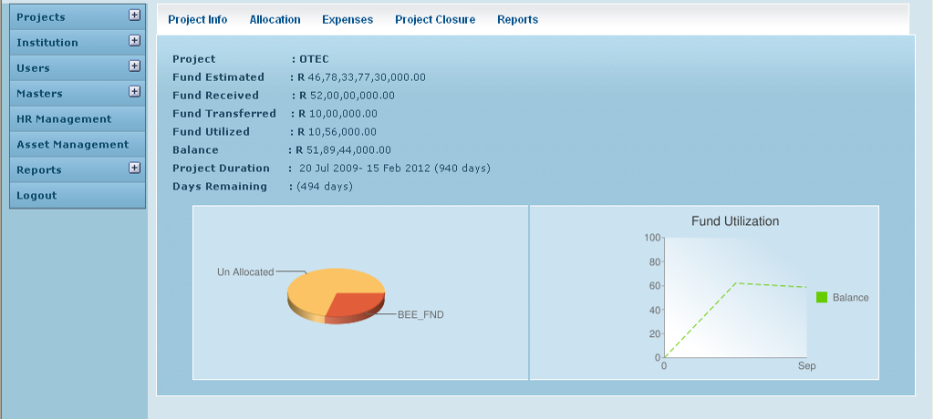

Field /Label | Input-Control | Data Type | Remarks / db table > field
Project | Auto-populated | varchar(255) | projects>code
Fund Estimated | Auto-populated | double | grant_allocation>amount_allocated
Fund Received | Auto-populated | double | grant_receipt>amount
Fund Transferred | Auto-populated | double | sum of all values of fund_transfer>amount
Fund Utilized | Auto-populated | double | sum of all values of grant_expense> expense_amount+ fund_transfer>amount
Balance | Auto-populated | double | Fund Received - Fund Transferred - Fund Utilized
Project Duration | Auto-populated | varchar(255) | difference between the values in projects>project_end_date and projects>project_start_date
Days Remaining | Auto-populated | varchar(255) | difference between the values in projects>project_end_date and current_date

Two graphical representations have been provided to give an easy view of grant allocation amongst account heads; and fund utilization with time, respectively.

Pie Chart – Account Headwise Allocation

Chart Component | Value/Requirement | Remarks/db table>field
Chart type | 3D pie chart
Chart size (width x height) | 290 x 90 pixels
Chart color (slices) | e25d3a,fb363
Chart background fill solid color | cbe2f 0
Chart area gradient fill at angle 45’ color | cbe2f 0  color centre point is 0  cbe2f 0  color centre point is 1
Chart Title | Fund Allocation
Chart title color, font size | 0000ff,1
Chart data | amounts allocated to different account heads | grant_allocation_split>amount;  (grant_allocation>amount_allocated)-(sum of all grant_allocation_split>amount) should be a data and labeled as “unallocated” amount
Slice Labels | account head names | account_heads>name
Legend position | Legend to the right of the chart, legend entries in a vertical column.

Line Graph – Fund Utilization

Chart Component | Value/Requirement | Remarks/db table>field
Chart type | A line chart where data points are spaced evenly along the x-axis. Axis lines are shown by default.
Axes to display | X (bottom) Y(left)
Axis labels to show (X) | X: Months in format – mmm (Start value: month of first expense entry; End value: month of current date)
Axis labels to show (Y) | 0:|0|20|40|60|80|100
Chart size (width x height) | 250 x 180 pixels
Chart color (slices) | 66CC00,3399ff
Chart background fill solid color | cbe2f 0
Chart area gradient fill at angle 45’ color | FFFFFF  color centre point is 0  cbe2f 0  color centre point is 1
Chart Title | Fund Utilization
Chart title color, font size | 0000ff,1
Chart data | (total expenses / total funds allocated) *100 |  | total expenses: sum of all values of:  grant_expense>expense_amount  total funds allocated: sum of all values of grant_allocation_split>amount
Legend position | Legend to the right of the chart, legend entries in a vertical column.

Associated Tables

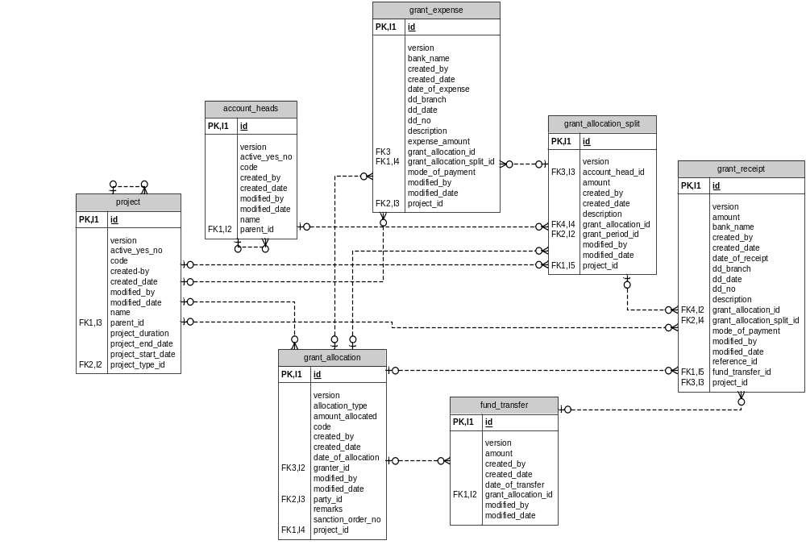

Data Dictionary

account_heads

Fields

Field | Type | Collation | Null | Key | Default | Extra | Privileges | Comment
id | bigint(20) | (NULL) | NO | PRI | (NULL) | auto_increment | select,insert,update,references
version | bigint(20) | (NULL) | NO |  |  |  | select,insert,update,references
active_yes_no | char(1) | latin1_swedish_ci | NO |  |  |  | select,insert,update,references
code | varchar(255) | latin1_swedish_ci | NO |  |  |  | select,insert,update,references
created_by | varchar(255) | latin1_swedish_ci | NO |  |  |  | select,insert,update,references
created_date | datetime | (NULL) | YES |  | (NULL) |  | select,insert,update,references
modified_by | varchar(255) | latin1_swedish_ci | NO |  |  |  | select,insert,update,references
modified_date | datetime | (NULL) | YES |  | (NULL) |  | select,insert,update,references
name | varchar(255) | latin1_swedish_ci | NO |  |  |  | select,insert,update,references
parent_id | bigint(20) | (NULL) | YES | MUL | (NULL) |  | select,insert,update,references

Indexes

Table | Non  unique | Key  name | Seq  in  index | Column  name | Collation | Cardinality | Sub  part | Packed | Null | Index  type | Comment
account_heads | 0 | PRIMARY | 1 | id | A | 21 | (NULL) | (NULL) |  | BTREE
account_heads | 1 | FKE001C601C4F4CD56 | 1 | parent_id | A | 10 | (NULL) | (NULL) | YES | BTREE

Foreign Key Relationships

FK Id | Reference Table | Source Column | Target Column | Extra Info
FKE001C601C4F4CD56 | account_heads | `parent_id` | `id`

fund_transfer

Fields

Field | Type | Collation | Null | Key | Default | Extra | Privileges | Comment
id | bigint(20) | (NULL) | NO | PRI | (NULL) | auto_increment | select,insert,update,references
version | bigint(20) | (NULL) | NO |  |  |  | select,insert,update,references
amount | double | (NULL) | NO |  |  |  | select,insert,update,references
created_by | varchar(255) | latin1_swedish_ci | NO |  |  |  | select,insert,update,references
created_date | datetime | (NULL) | YES |  | (NULL) |  | select,insert,update,references
date_of_transfer | datetime | (NULL) | NO |  |  |  | select,insert,update,references
grant_allocation_id | bigint(20) | (NULL) | NO | MUL |  |  | select,insert,update,references
modified_by | varchar(255) | latin1_swedish_ci | NO |  |  |  | select,insert,update,references
modified_date | datetime | (NULL) | YES |  | (NULL) |  | select,insert,update,references

Indexes

Table | Non  unique | Key  name | Seq  in  index | Column  name | Collation | Cardinality | Sub  part | Packed | Null | Index  type | Comment
fund_transfer | 0 | PRIMARY | 1 | id | A | 105 | (NULL) | (NULL) |  | BTREE
fund_transfer | 1 | FK45181425B8D959F3 | 1 | grant_allocation_id | A | 105 | (NULL) | (NULL) |  | BTREE

Foreign Key Relationships

FK Id | Reference Table | Source Column | Target Column | Extra Info
FK45181425B8D959F3 | grant_allocation | `grant_allocation_id` | `id`

grant_allocation

Fields

Field | Type | Collation | Null | Key | Default | Extra | Privileges
id | bigint(20) | (NULL) | NO | PRI | (NULL) | auto_increment | select,insert,update,references
version | bigint(20) | (NULL) | NO |  |  |  | select,insert,update,references
allocation_type | varchar(255) | latin1_swedish_ci | NO |  |  |  | select,insert,update,references
amount_allocated | double | (NULL) | NO |  |  |  | select,insert,update,references
code | varchar(255) | latin1_swedish_ci | NO |  |  |  | select,insert,update,references
created_by | varchar(255) | latin1_swedish_ci | NO |  |  |  | select,insert,update,references
created_date | datetime | (NULL) | YES |  | (NULL) |  | select,insert,update,references
date_of_allocation | datetime | (NULL) | NO |  |  |  | select,insert,update,references
granter_id | bigint(20) | (NULL) | YES | MUL | (NULL) |  | select,insert,update,references
modified_by | varchar(255) | latin1_swedish_ci | NO |  |  |  | select,insert,update,references
modified_date | datetime | (NULL) | YES |  | (NULL) |  | select,insert,update,references
party_id | bigint(20) | (NULL) | NO | MUL |  |  | select,insert,update,references
projects_id | bigint(20) | (NULL) | NO | MUL |  |  | select,insert,update,references
remarks | varchar(255) | latin1_swedish_ci | NO |  |  |  | select,insert,update,references
sanction_order_no | varchar(255) | latin1_swedish_ci | YES |  | (NULL) |  | select,insert,update,references

Indexes

Table | Non  unique | Key  name | Seq  in  index | Column  name | Collation | Cardinality | Sub  part | Packed | Null | Index  type | Comment
grant_allocation | 0 | PRIMARY | 1 | id | A | 433 | (NULL) | (NULL) |  | BTREE
grant_allocation | 1 | FK221B5BE337914517 | 1 | granter_id | A | 48 | (NULL) | (NULL) | YES | BTREE
grant_allocation | 1 | FK221B5BE34B78CFDA | 1 | party_id | A | 108 | (NULL) | (NULL) |  | BTREE
grant_allocation | 1 | FK221B5BE3905C4B9A | 1 | projects_id | A | 433 | (NULL) | (NULL) |  | BTREE

Foreign Key Relationships

FK Id | Reference Table | Source Column | Target Column | Extra Info
FK221B5BE3905C4B9A | projects | `projects_id` | `id` | ,
FK221B5BE337914517 | party | `granter_id` | `id` | ,
FK221B5BE34B78CFDA | party | `party_id` | `id`

grant_allocation_split

Fields

Field | Type | Collation | Null | Key | Default | Extra | Privileges
id | bigint(20) | (NULL) | NO | PRI | (NULL) | auto_increment | select,insert,update,references
version | bigint(20) | (NULL) | NO |  |  |  | select,insert,update,references
account_head_id | bigint(20) | (NULL) | NO | MUL |  |  | select,insert,update,references
amount | double | (NULL) | NO |  |  |  | select,insert,update,references
created_by | varchar(255) | latin1_swedish_ci | NO |  |  |  | select,insert,update,references
created_date | datetime | (NULL) | NO |  |  |  | select,insert,update,references
description | varchar(255) | latin1_swedish_ci | NO |  |  |  | select,insert,update,references
grant_allocation_id | bigint(20) | (NULL) | YES | MUL | (NULL) |  | select,insert,update,references
grant_period_id | bigint(20) | (NULL) | NO | MUL |  |  | select,insert,update,references
modified_by | varchar(255) | latin1_swedish_ci | YES |  | (NULL) |  | select,insert,update,references
modified_date | datetime | (NULL) | YES |  | (NULL) |  | select,insert,update,references
projects_id | bigint(20) | (NULL) | NO | MUL |  |  | select,insert,update,references

Indexes

Table | Non  unique | Key  name | Seq  in  index | Column  name | Collation | Cardinality | Sub  part | Packed | Null | Index  type
grant_allocation_split | 0 | PRIMARY | 1 | id | A | 136 | (NULL) | (NULL) |  | BTREE
grant_allocation_split | 1 | FK49B723BE161A26D3 | 1 | grant_  period_id | A | 8 | (NULL) | (NULL) |  | BTREE
grant_allocation_split | 1 | FK49B723BE3036284E | 1 | account_  head_id | A | 34 | (NULL) | (NULL) |  | BTREE
grant_allocation_split | 1 | FK49B723BEB8D959F3 | 1 | grant_  allocation_id | A | 136 | (NULL) | (NULL) | YES | BTREE
grant_allocation_split | 1 | FK49B723BE905C4B9A | 1 | projects_id | A | 136 | (NULL) | (NULL) |  | BTREE

Foreign Key Relationships

FK Id | Reference Table | Source Column | Target Column | Extra Info
FK49B723BE905C4B9A | projects | `projects_id` | `id` | ,
FK49B723BE161A26D3 | grant_period | `grant_period_id` | `id` | ,
FK49B723BE3036284E | account_heads | `account_head_id` | `id` | ,
FK49B723BEB8D959F3 | grant_allocation | `grant_allocation_id` | `id`

grant_expense

Fields

Field | Type | Collation | Null | Key | Default | Extra | Privileges
id | bigint(20) | (NULL) | NO | PRI | (NULL) | auto_increment | select,insert,update,references
version | bigint(20) | (NULL) | NO |  |  |  | select,insert,update,references
bank_name | varchar(255) | latin1_swedish_ci | NO |  |  |  | select,insert,update,references
created_by | varchar(255) | latin1_swedish_ci | NO |  |  |  | select,insert,update,references
created_date | datetime | (NULL) | NO |  |  |  | select,insert,update,references
date_of_expense | datetime | (NULL) | NO |  |  |  | select,insert,update,references
dd_branch | varchar(255) | latin1_swedish_ci | NO |  |  |  | select,insert,update,references
dd_date | datetime | (NULL) | NO |  |  |  | select,insert,update,references
dd_no | varchar(255) | latin1_swedish_ci | NO |  |  |  | select,insert,update,references
description | varchar(255) | latin1_swedish_ci | NO |  |  |  | select,insert,update,references
expense_amount | double | (NULL) | NO |  |  |  | select,insert,update,references
grant_allocation_id | bigint(20) | (NULL) | YES | MUL | (NULL) |  | select,insert,update,references
grant_allocation_split_id | bigint(20) | (NULL) | YES | MUL | (NULL) |  | select,insert,update,references
mode_of_payment | varchar(255) | latin1_swedish_ci | NO |  |  |  | select,insert,update,references
modified_by | varchar(255) | latin1_swedish_ci | YES |  | (NULL) |  | select,insert,update,references
modified_date | datetime | (NULL) | YES |  | (NULL) |  | select,insert,update,references
projects_id | bigint(20) | (NULL) | NO | MUL |  |  | select,insert,update,references

Indexes

Table | Non  unique | Key  name | Seq  in  index | Column  name | Collation | Cardinality | Sub  part | Packed | Null | Index  type
grant_expense | 0 | PRIMARY | 1 | id | A | 80 | (NULL) | (NULL) |  | BTREE
grant_expense | 1 | FK33905435B8D959F3 | 1 | grant_allocation_id | A | 80 | (NULL) | (NULL) | YES | BTREE
grant_expense | 1 | FK33905435905C4B9A | 1 | projects_id | A | 80 | (NULL) | (NULL) |  | BTREE
grant_expense | 1 | FK3390543533CE82BA | 1 | grant_allocation_  split_id | A | 80 | (NULL) | (NULL) | YES | BTREE

Foreign Key Relationships

FK Id | Reference Table | Source Column | Target Column | Extra Info
FK3390543533CE82BA | grant_allocation_split | `grant_allocation_split_id` | `id` | ,
FK33905435905C4B9A | projects | `projects_id` | `id` | ,
FK33905435B8D959F3 | grant_allocation | `grant_allocation_id` | `id`

grant_receipt

Fields

Field | Type | Collation | Null | Key | Default | Extra | Privileges
id | bigint(20) | (NULL) | NO | PRI | (NULL) | auto_increment | select,insert,update,references
version | bigint(20) | (NULL) | NO |  |  |  | select,insert,update,references
amount | double | (NULL) | NO |  |  |  | select,insert,update,references
bank_name | varchar(255) | latin1_swedish_ci | YES |  | (NULL) |  | select,insert,update,references
created_by | varchar(255) | latin1_swedish_ci | NO |  |  |  | select,insert,update,references
created_date | datetime | (NULL) | NO |  |  |  | select,insert,update,references
date_of_receipt | datetime | (NULL) | NO |  |  |  | select,insert,update,references
dd_branch | varchar(255) | latin1_swedish_ci | YES |  | (NULL) |  | select,insert,update,references
dd_date | datetime | (NULL) | YES |  | (NULL) |  | select,insert,update,references
dd_no | varchar(255) | latin1_swedish_ci | YES |  | (NULL) |  | select,insert,update,references
description | varchar(255) | latin1_swedish_ci | NO |  |  |  | select,insert,update,references
grant_allocation_id | bigint(20) | (NULL) | YES | MUL | (NULL) |  | select,insert,update,references
grant_allocation_split_id | bigint(20) | (NULL) | YES | MUL | (NULL) |  | select,insert,update,references
mode_of_payment | varchar(255) | latin1_swedish_ci | NO |  |  |  | select,insert,update,references
modified_by | varchar(255) | latin1_swedish_ci | YES |  | (NULL) |  | select,insert,update,references
modified_date | datetime | (NULL) | YES |  | (NULL) |  | select,insert,update,references
projects_id | bigint(20) | (NULL) | NO | MUL |  |  | select,insert,update,references
reference_id | varchar(255) | latin1_swedish_ci | NO |  |  |  | select,insert,update,references
fund_transfer_id | bigint(20) | (NULL) | YES | MUL | (NULL) |  | select,insert,update,references

Indexes

Table | Non  unique | Key  name | Seq  in  index | Column  name | Collation | Cardinality | Sub  part | Packed | Null | Index  type
grant_receipt | 0 | PRIMARY | 1 | id | A | 63 | (NULL) | (NULL) |  | BTREE
grant_receipt | 1 | FKC21DFE15B8D959F3 | 1 | grant_allocation_id | A | 63 | (NULL) | (NULL) | YES | BTREE
grant_receipt | 1 | FKC21DFE15905C4B9A | 1 | projects_id | A | 63 | (NULL) | (NULL) |  | BTREE
grant_receipt | 1 | FKC21DFE1533CE82BA | 1 | grant_allocation_split_id | A | 63 | (NULL) | (NULL) | YES | BTREE
grant_receipt | 1 | FKC21DFE15E6A7AD65 | 1 | fund_transfer_id | A | 63 | (NULL) | (NULL) | YES | BTREE

Foreign Key Relationships

FK Id | Reference Table | Source Column | Target Column | Extra Info
FKC21DFE15E6A7AD65 | fund_transfer | `fund_transfer_id` | `id` | ,
FKC21DFE1533CE82BA | grant_allocation_split | `grant_allocation_split_id` | `id` | ,
FKC21DFE15905C4B9A | projects | `projects_id` | `id` | ,
FKC21DFE15B8D959F3 | grant_allocation | `grant_allocation_id` | `id`

